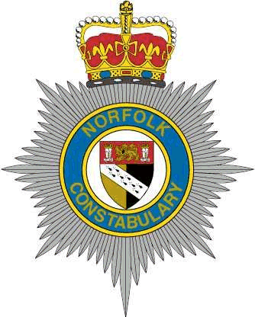

7 Force ERSOU Application Approval Form

Please Specify via Tick box which force you are applying from.
If you are an external candidate please complete part A as Part B on page 2 will not apply for you.

Bedfordshire | ☐
Cambridgshire | ☐
Hertfordshire | ☐
Norfolk | ☐
Suffolk | ☐
Essex | ☐
Kent | ☐
External | ☐

Part A

Post Title:

Advert Reference Number:

Full Name:

Collar / Warrant Number:

Current Role and Team (if applicable):

Current CSP / District / Department:

Home Force:

Part B
First Line Manager’s Name:

Line Manager’s Comments:

Signature of Line Manager:

Chief Inspector/Department Head:

Chief Inspector/Department Head Comments:

Signature of Chief Inspector/Department Head :

Notes:

Once completed please return this form fully completed to the BCHCareers Mailbox (BCHCareers@Herts.pnn.police.uk) at the same time you submit your application (including if on-line).

Please note that if you do not submit this form fully completed, we will not be able to progress your application. If you have any queries in relation to this form please contact Human Resources at BCHCareers@Herts.pnn.police.uk
- For Herts Police Officers – please also pass a copy of this form to your relevant Superintendent.

