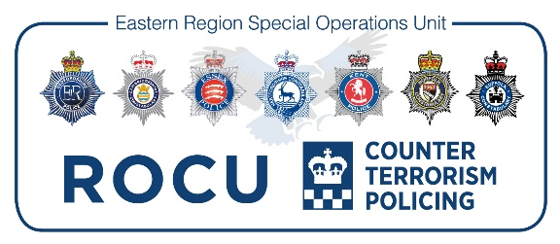

Recruitment Process – Summary for Applicants (Officers)

Thank you for your interest in applying for a role within ERSOU. Due to the nature of the service we provide and in the interest of recruiting the best candidates to reduce crime, catch criminals and keep the people of our County safe, our recruitment process may be more comprehensive than other processes you have experienced. We are very interested in your application – please bear with us whilst all the necessary assessments and checks are undertaken.

Please do not hand in your notice to your current employer until a final offer has been made to you.
Application Process
Ensure you complete all boxes with an asterisk (*) or you will be unable to submit your application. Please ensure you complete the minimum entry requirements and competencies in the supporting statement section, these vary depending on the role and will be explained on the accompanying advert and role profile.
Please note there is a word count limit on the applications and you should ensure your evidence fits within this limit.
If additional criteria questions are asked, please ensure that you provide evidence against these.
Shortlisting
Candidates are shortlisted by assessing the information on the application form against the personal qualities/competencies and minimum entry requirements. It is important that you, therefore, complete the application form fully and carefully, ensuring you demonstrate with examples how you meet the criteria detailed on the role profile and advert.
If additional criteria questions are asked, these will also be assessed.
Interview/Selection process
If invited to interview you will be notified via email, this notification will usually be a minimum of seven days before the interview date. You will be required to produce valid identification at the interview (a list of suitable ID will be sent via email) for photocopies to be made.
If your recruitment process includes your attendance at an assessment, all information will be provided via email, for example certain roles may require you to complete a technical test.
During the interview you could be asked about all or any of the six competencies stipulated in the role profile. You would also be informed prior to interview if there is a presentation or test element to the selection process.
Offer of Secondment
If you are successful following the selection process you will receive an offer of secondment. We will start progressing your pre-employment checks which involves various forms of vetting.
For some roles if you are successful at the interview/selection stage you will be advised that you will be placed on a waiting list until the next available position.
Vetting
Vetting is required for all employees and levels of vetting differ across the categories of vacancies. ERSOU employees require Management Vetting (MV) and National Security Checks (SC). You may also need to undergo STRAP vetting, this form will be provided at the conditional offer stage.
For Management Vetting you will be sent an e-form, this must be completed online and returned via email to the necessary address.
Vetting completion varies in individual cases so please allow a minimum of four weeks for vetting checks to be finalised for MV. Once MV vetting is complete SC forms will be sent via the relevant vetting department and will require you to log in and complete further vetting forms. Vetting clearance for SC does vary, but usually takes between six and twelve weeks.
STRAP clearance will not begin until MV & SC is complete. STRAP completion normally takes two weeks.
Some roles will allow you to begin whilst Security Checks are being completed. If this applies to you your HR contact will email to explain and ask if you are happy to proceed. You can decide to wait for all vetting to be complete before beginning the role. This option is not available if STRAP is required.
Secondment Agreement
Once all pre-employment checks have been concluded and approved we will contact your home force to negotiate/confirm a release date.
Once a release date has been agreed, a secondment agreement will be issued with the relevant shift pattern.
Start date
You will be provided with a contact and start time for your first day. This will be followed by an induction into your role (this varies depending on the department/role).
Further information
If you require any further information or need clarity on any of the above points please don’t hesitate to contact us.
Telephone: 01438 757777
Email: ersou.recruitment@herts.pnn.police.uk

