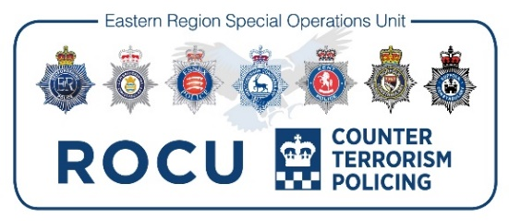

7 Force ROCU Application Approval Form

Please Specify via Tick box which force you are applying from.
If you are an external candidate please complete part A as Part B on page 2 will not apply for you.

Bedfordshire | ☐
Cambridgshire | ☐
Hertfordshire | ☐
Norfolk | ☐
Suffolk | ☐
Essex | ☐
Kent | ☐
External | ☐

Part A

Post Title:

Vacancy Reference Number: | Closing Date of Vacancy:
Full Name:

Collar / Warrant Number:

Current Role and Team (if applicable):

Current CSP / District / Department:

Home Force:

Part B
First Line Manager’s Name:

Line Manager’s Comments:

Application Supported (see line manager guidance below): | YES | NO
Signature of Line Manager:

Chief Inspector/Department Head:

Chief Inspector/Department Head Comments:

Application Supported: | YES | NO
Signature of Chief Inspector/Department Head:

Notes:

Please return this form fully completed to the ERSOU RECRUITMENT Mailbox (ersou.recruitment@herts.pnn.police.uk) at the same time you submit your application.

Please note that if you do not submit this form fully completed, we will not be able to progress your application. If you have any queries in relation to this form please contact Human Resources at ersou.recruitment@herts.pnn.police.uk
- For Herts Police Officers – please also pass a copy of this form to your relevant Superintendent.
- For Essex or Kent Police Officers – once completed please forward to HR.resource.planning@kent.essex.pnn.police.uk

Line Manager Guidance

Please note that it is your responsibility to notify your Head of Department of this individual’s application.

If you feel this application is not appropriate to continue to short listing please could you provide an evidence based response under one or more of the reasons outlined below:

- Individual being managed under UPP (Attendance or Performance).
- Individual has live misconduct warnings or is subject to an on-going investigation
- There is and approved Return on Investment minimum posting period in place for current role which is not yet complete

Please ensure you discuss the content of your response with the individual and ensure they are copied into your response.

The information you provide will be shared with the Recruiting Manager and this will be considered alongside their application form.

Posting between business areas – the designated command/department officer releasing the officer will agree a date for posting with the receiving designated command/department officer. The posting will take place within 6 weeks of the offer of a job. In exceptional circumstances, where significant risks are identified, the posting may be as late as 12 weeks, but full account will be taken of the published strategic resourcing priorities for that force in agreeing the posting date.

Disputes
Any disputes about posting or the release of officers within force will be discussed by the designated managers with the Chief Officer HR lead for the force who will make a determination.
Any disputes about posting or the release of officers between a force and a collaborative unit will be discussed by the designated managers with the Chief Officer HR lead for the force and the relevant Chief Officer for the collaborated unit.

