

**Application & Assessment Centre Guidance**

**Your journey to becoming a**

**Bedfordshire Police Special Constable**



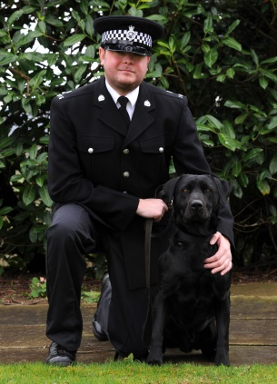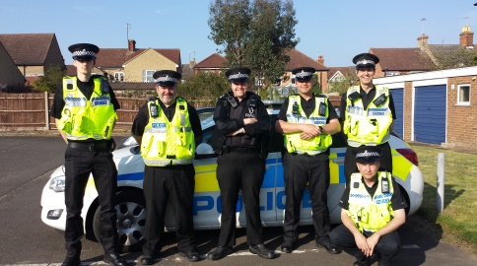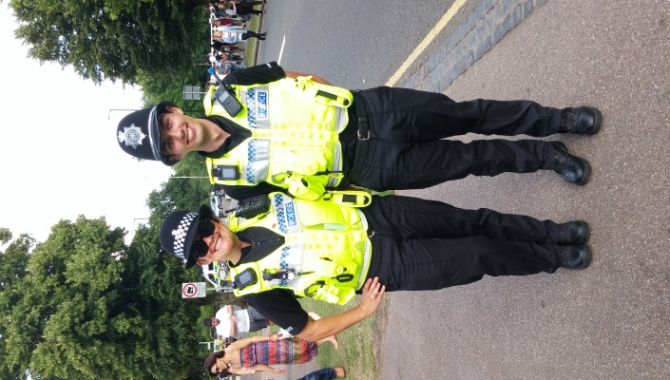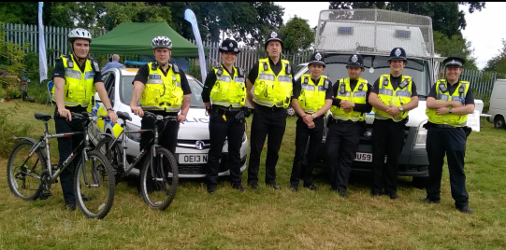

**Contents**

Letter from the Chief Officer…………………………………………………..Page 3

Letter from the Chief Constable ……………………………………………..Page 3

About Citizens in Policing…………………………………………….………Page 4

Key Contacts…………………………………………………………………..Page 5

Eligibility…………………………………….………………………………….Page 5

Application and Recruitment Process………………………………………Pages 6-7

A Guide to the Application Form……………………………………………Page 8

Toolkit, Advice and Tips …………………………………………………….Pages 9-10

Special Constable Competencies……………………………………….….Pages 10-12

What else does the application cover? ...................................................Page 13

Frequently asked questions & Key Information……………………………Pages 14-15

Meet our special constables…………………………………………………Pages 16-17

Notes page…………………………………………………………………….Page 18

**This is your booklet, so please use it however you would like to, whether that’s to make notes at the notes page provided at the back to record key contacts, gather ideas for your application form or the assessment centre or just to find out more about Bedfordshire’s Special Constabulary**

**Letter from the Chief Officer**

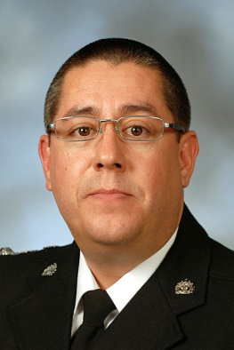Thank you for your interest in volunteering with Bedfordshire Police’s Special Constabulary.

Bedfordshire Police is proud to serve our communities and put their needs at the heart of our work. The Special Constabulary supports frontline policing in the county, and deals with an ever increasing, diverse range of activities.

Most recently our Specials have joined the Operation Meteor team, and are helping to disrupt nuisance biker activity in the county.

As a Special you will develop personally and professionally, combining your skills and experiences with the training that we offer. You’ll learn skills which may help you in your current line of work or to gain employment.

I volunteer with the Special Constabulary alongside my day job, and it is one of the most rewarding things I have done. I am privileged to work alongside some incredibly dedicated people already, and I am looking forward to welcoming you to the team.



Clint Sharp

Special Constabulary Chief Officer

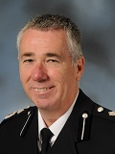**Letter from the Chief Constable**

Special Constables play a vital role in helping to keep our communities safe. Through preventing and investigating crime, tackling anti-social behaviour and reducing disorder, Specials provide a much appreciated active presence in all areas.

As a Special Constable you will be working for the benefit of the community. That is why we are keen to recruit people from all walks of life and a range of different cultural and ethnic backgrounds because we know you better understand the real issues and concerns facing those who live and work in your neighbourhood.

Work with us to protect people and fight crime together.



Jon Boutcher QPM

Chief Constable, Bedfordshire Police



**About Citizens in Policing**

‘Citizens in Policing’ is the term used to describe the thousands of people across the UK who volunteer their time to support the police.

The role of the citizens in policing is vital – volunteers increase the capacity of the Bedfordshire Police, bringing valuable skills and expertise to police teams, creating closer and more effective relationships with our communities, giving up their free time to volunteer in a variety of policing roles for various reasons.

“The contribution that volunteers make to the police service is staggering. Every day thousands of people across the UK give up their time to increase the capacity of police forces and bring vital skills. This is all about connecting policing to communities and communties to policing.

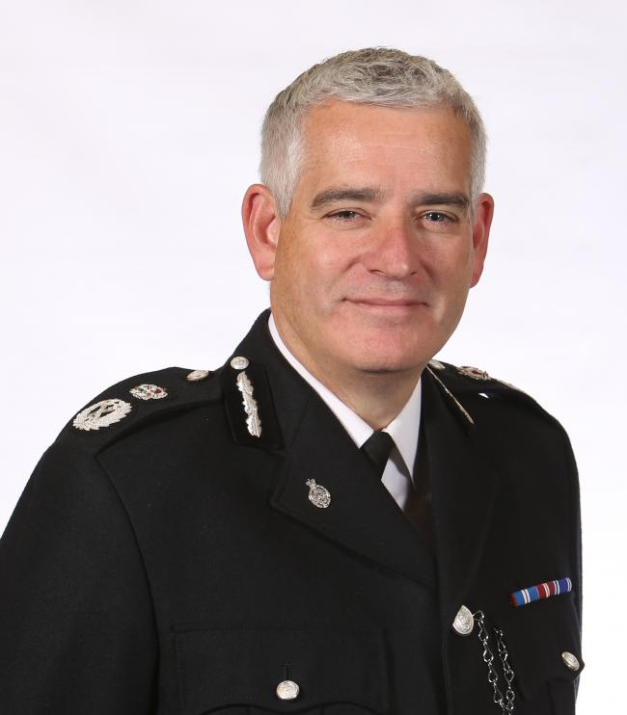

“They provide links to the communities in which we serve and help us to respond to the rapidly changing demand we face.

“On behalf of the constabularies across the country, I offer my thanks to our volunteer colleagues and hope that this document provides information and insight to anyone considering joining the policing family”.

**Chief Constable Dave Jones, National Lead for Citizens in Policing.**

At Bedfordshire Police, we currently have a strong Citizens in Policing Unit with passionate members of staff who support, coach and mentor the volunteering community.

In order to develop the Citizens in Policing Unit, we will undertake several activities which can be adopted to improve recruitment and retention rates within Bedfordshire Police.

It is our ambition to target volunteers with particular skills and experience to fulfil non-traditional volunteering positions. We will adopt a robust marketing strategy using multiple media platforms and the latest technologies to improve our reach.

Our force is currently supported by over 700 Citizens in Policing, with a strong Cadet force of over 120. In addition we have 200 serving special constables. It is our ambition to increase the Special Constabulary substantially over the next two years.

**Key Contacts**

The Citizens in Policing Unit will be happy to help and answer any questions about the Special Constabulary, application process and training.

You can contact them via [CIP@bedfordshire.pnn.police.uk](mailto:CIP@bedfordshire.pnn.police.uk).

**Eligibility**

To apply for the Special Constabulary, you must be 18 years old and a British Citizen, an EC/EEA National or Commonwealth Citizen or a Foreign National with no restrictions to live & work in the UK.

Specific educational qualifications are not a requirement for this role.

If you have had any previous cautions or convictions please detail these on your application form. Dependent on the nature of the caution/conviction, this could lead you to be ineligible to apply.

Bedfordshire Police welcomes applications from candidates with disabilities and will do all it can to make reasonable adjustments.

Credit checks are made on all applicants and all debts will need to be discharged on application. If you have been declared bankrupt, you will have to have been discharged for five years before you are eligible to apply.

You do not need a driving licence at the time of submitting an application to become a Special Constable, but it is preferable if you do have one.

All applicants must be in good physical and mental health. If you pass the Assessment Centre you will attend a full medical with our Occupational Health Team.

You will be required to visit an optician to ensure your eyesight meets the standards required to become a Special Constable.

Tattoos are not acceptable if:

* They undermine the dignity and authority of the office of constable, are garish, numerous or particularly prominent
* They could cause offence to members of the public, colleagues and/or invite provocation. This would include tattoos that are; rude, lewd, crude, racist, sexist, sectarian, homophobic, violent or intimidating
* They display unacceptable attitudes towards women, minority groups, or any other section of the community, or alignment with particular groups that could be offensive to members of the community

**Application and Recruitment Process**

The interview and selection process is designed to test the following seven core competencies, deemed suitable for the role of a Police Officer which is constantly assessed through the full assessment process. The seven competencies are:

* We deliver, support and inspire
* We are collaborative
* We are innovative and open-minded
* We analyse critically
* We take ownership
* We are emotionally aware

**Stage One – Online Application**

You must complete the initial [application form online](https://tri-force.tal.net/vx/lang-en-GB/mobile-0/appcentre-3/brand-3/xf-dfa73b263cc9/candidate/so/pm/6/pl/1/opp/2412-Special-Constable-2015-2016/en-GB). You may also be subject to preliminary vetting checks at this stage.

**Stage Two – Telephone Interview**

If your application form is shortlisted to progress to the next stage then you will be offered an initial telephone interview for us to ascertain your suitability to progress to the Special Constabulary Assessment Centre. The interview will assess whether you understand the role of being a Special, the commitments required and your motivation for wanting to do it.

**Stage 3 – Assessment Centre**

You will be invited to attend an Assessment Centre at either Bedfordshire Police Headquarters or Halsey Road Police Station in Kempston. The Assessment Centre will last for approx. half a day consisting of the following assessments:

* Job Related Fitness Test
* One Group Assessment
* One Observational Test

You must first pass the fitness test in the first instance to progress further through the assessment centre. If you do not pass the fitness test then you will be provided with feedback and advice and invited to attend a subsequent assessment centre.

You will need to complete all elements of the assessment centre successfully to enable you to progress to the pre-employment checks (vetting, references, medical)

**DRESS CODE FOR ATTENDANCE AT THE ASSESSMENT CENTRE:** You will be required to undertake a fitness test as the first stage of the assessment. Therefore, please arrive at the assessment centre dressed in training/sportswear with sensible footwear appropriate for jogging/running. Please do not wear fashion trainers, converse or plimsolls as you will not be permitted to participate in any part of the assessment centre.

**Job Related Fitness Test**

You will be asked to complete the bleep test: running between two lines (approximately 15 metres apart) in time with a series of bleeps. If you arrive at the end line before the bleep sounds you need to wait for the bleep before resuming running, adjusting your speed.

The timing between bleeps is slow at first but become faster as the test progresses and it becomes more difficult to keep up with the required speed. You will run until you can no longer keep up with the set pace. You will need to reach a minimum of level 5.4 to pass.

To prepare yourself and improve your stamina you should take part in sporting activities which last 30 minutes or more and get you out of breath such as football, netball or squash or activities which create a large aerobic demand such as jogging, cycling, swimming or rowing.

Try jogging for 20 minutes or more and as you improve, increase the distance covered in that time. Alternatively jog a set distance from home and back again and try to reduce the time taken to cover the distance. You should exercise three times a week for 20 minutes but if you are not used to exercise you should start with gentle sessions lasting no more than 15 minutes.

**Stage Four - Training**

The Initial Learning for Special Constables (ILSC) is a training programme consisting of training in criminal law, legal powers, traffic offences, policies, procedures, communication and radio use, practical policing skills, IT systems, self-defence and first-aid.

Prior to undertaking any police patrol duties, you will undergo an initial training course. The course is currently delivered over an eight week period which will consist of classroom and computer based learning which cover many aspects of law and procedure.  This will take place on a Tuesday and Thursday evenings. Your Personal Safety training will be delivered on each Saturday during the course.

We are sometimes able to offer a three-week intensive course and the Special Constable Training Officers can provide more information on this course. Options can be discussed once you have successfully completed the Assessment Centre.

There is an attestation at the end of training to mark the successful completion of the course.

After initial training and attestation you will have further training sessions as well as being out on patrol as a Special Constable. During your first 2 years you will be working towards the completion of your Police Action Checklist (PAC). The checklist consists of units which relate to arresting, searching and responding to incidents and needs to be completed before you can patrol independently.

Policing never stands still, so you are expected to keep yourself abreast of changing law, policy and procedure. There will be various duties and continued training events to assist with the ongoing changes.

**More information**

**Vetting**

Following successful completion of the Assessment Centre you will be required to complete a recruitment vetting e-form which will ask more details about you and those you live with. You will also be required to undertake biometric vetting, which involves your DNA and fingerprints being obtained. Further details will be provided at the time.

**Medical**

Candidates will be provided with a work health questionnaire that must be completed and sent directly to the Occupational Health Department. A full medical history must be disclosed as failure to do so may result in your application being rejected. Please complete the questionnaire carefully and thoroughly – if in doubt, disclose it.

**A Guide to the Application Form**

This is an online application form to assess your suitability to be considered for the role of Special Constable. We will be seeking evidence of your understanding of the role and how you can provide Bedfordshire Police with the skills required drawing on your past actions, behaviours and experiences to see if you’ve got what it takes to be a part of Bedfordshire’s Special Constabulary.

When you’re filling out your application form there’s one thing that you need to remember – we don’t know you. Make your talents shine through by writing clear answers, backed up with lots of examples. Saying that you’re ‘hard working’ or ‘a good communicator’ isn’t enough. Instead tell us a structured story and provide details on the specific competency that relates to the question. Reading the question carefully should ensure that your answers are relevant and to the point.

Last but not least we’ll check your application for spelling and grammar errors, and if you have more than 10 it will automatically fail. Make sure this doesn’t happen to you by using the spelling and grammar check on your computer or asking someone to read your application through. We would suggest preparing your evidence on a word-processing package such as MS Word, and then cut and paste into the application form once you have double checked it.

You can use examples from your work or social life, or of situations you have come across, it does not have to be police orientated but does need to demonstrate the qualities we look for.

There are further hints and tips below which you will need to consider in preparation for your telephone interview::

**Toolkit**

Use the **STAR** acronym to structure your story and provide one specific example for each of the questions:

**ST** - A brief description of the **situation or task**

**A** - Details of the **actions** YOU took - use action verbs

**R** – The **results** or outcome achieved

**What is good evidence?**

* Give specific examples explaining ‘how’ not ‘what’
* Do not be vague or ambiguous
* Do not use multiple examples – one or two good examples is better than several weak ones
* Describe what part **you** played in the example you provide. “I broke down barriers of mistrust”, is no good. Explain **what you did**, for example: “I broke down the barriers of mistrust between ****** by explaining the support offered and asking what else ****** needed.”
* Be careful of statements. Rather than saying “it is important that we engage the community” you should evidence how you are engaging the community
* Demonstrate your awareness of the various factors that needed to be taken into account during the situation you’re writing about

Actions verbs and their use – remember it’s the ‘what’ plus ‘how’:

* I tasked … to ...
* I organised … to …
* I kept … informed which meant…
* My work led to …
* I decided / I made the decision
* I gained the support of … by
* I considered … which meant / led to …
* I recognised … so I negotiated …
* I briefed …
* My actions led to …
* I took responsibility by …
* I established … by …

Other action verbs include:

* analyse
* apply
* change
* create
* determine
* differentiate
* identify

When writing about the results and outcomes remember to:

* Give clear examples,
* Supply any facts or statistic that strengthen your answer,
* Make sure you give a conclusion to you example, whether the outcome was good or bad,
* Consider what you may do different next time if the outcome was not positive.

Avoid jargon, words and phrases which are (or can be constructed as) misleading or ambiguous such as:

* ‘be aware of’
* ‘have an awareness of’
* Does your example male sense? Remember that the assessor does not know you or the background to your examples, so you need to ensure that you provide context and that your examples are well structured.

**Special Constable Competencies**

| Police Performance Framework |  |
| --- | --- |
| Technical Skills and Behavioural competencies may be used for promotion / recruitment / selection / PDR processes | | |
| **Skill Category: Cluster** | |  |
| Inclusive, Enabling and Visionary Leadership | We deliver, support and inspire    ¦ I take on challenging tasks to help to improve the service continuously and  support my colleagues.  ¦ I understand how my work contributes to the wider police service.  ¦ I understand it is part of my collective responsibility to deliver efficient  services. I take personal responsibility for making sure that I am working  effectively to deliver the best service, both individually and with others.  ¦ I am conscientious in my approach, working hard to provide the best service  and to overcome any obstacles that could prevent or hinder delivery.  ¦ I support the efficient use of resources to create the most value and to  deliver the right impact.  ¦ I keep up to date with changes in internal and external environments.  ¦ I am a role model for the behaviours I expect to see in others and I act in the  best interests of the public and the police service |  |
| Inclusive, Enabling and Visionary Leadership | We are collaborative    ¦ I work cooperatively with others to get things done, willingly giving help  and support to colleagues.  ¦ I am approachable, and explain things well so that I generate a  common understanding.  ¦ I take the time to get to know others and their perspective in order to  build rapport.  ¦ I treat people with respect as individuals and address their specific  needs and concerns.  ¦ I am open and transparent in my relationships with others.  ¦ I ensure I am clear and appropriate in my communications. |  |
| Intelligent, Creative and Informed Policing | We are innovative and open-minded    ¦ I demonstrate an openness to changing ideas, perceptions and ways  of working.  ¦ I share suggestions with colleagues, speaking up to help improve existing  working methods and practices.  ¦ I constantly reflect on my own way of working and periodically review  processes and procedures to make continuous improvements.  ¦ I adapt to change and am flexible as the need arises while encouraging  others to do the same.  ¦ I learn from my experiences and do not let myself be unduly influenced  by preconceptions. |  |
| Intelligent, Creative and Informed Policing | We analyse critically    ¦ I recognise the need to think critically about issues. I value the use of  analysis and testing in policing.  ¦ I take in information quickly and accurately.  ¦ I am able to separate information and decide whether it is irrelevant or  relevant and its importance.  ¦ I solve problems proactively by understanding the reasons behind them,  using learning from evidence and my experiences to take action.  ¦ I refer to procedures and precedents as necessary before making decisions.  ¦ I weigh up the pros and cons of possible actions, thinking about potential  risks and using this thinking to inform our decisions.  ¦ I recognise gaps and inconsistencies in information and think about the  potential implications.  ¦ I make decisions in alignment with our mission, values and the Code of Ethics. |  |
| Resolute, Compassionate and Committed | We take ownership    ¦ I actively identify and respond to problems.  ¦ I approach tasks with enthusiasm, focusing on public service excellence.  ¦ I regularly seek feedback to understand the quality of my work and the  impact of my behaviour.  ¦ I recognise where I can help others and willingly take on additional tasks to  support them, where appropriate.  ¦ I give feedback to others that I make sure is understandable and constructive.  ¦ I take responsibility for my own actions, I fulfil my promises and do what I say I will.  ¦ I will admit if I have made a mistake and take action to rectify this.  ¦ I demonstrate pride in representing the police service.  ¦ I understand my own strengths and areas for development and take  responsibility for my own learning to address gaps. |  |
| Resolute, Compassionate and Committed | We are emotionally aware    ¦ I treat others with respect, tolerance and compassion.  ¦ I acknowledge and respect a range of different perspectives, values and  beliefs within the remit of the law.  ¦ I remain calm and think about how to best manage the situation when faced  with provocation.  ¦ I understand my own emotions and I know which situations might affect my  ability to deal with stress and pressure.  ¦ I ask for help and support when I need it.  ¦ I understand the value that diversity offers.  ¦ I communicate in clear and simple language so that I can be easily  understood by others.  ¦ I seek to understand the thoughts and concerns of others even when they  are unable to express themselves clearly. |  |

**What else does the application form cover?**

**Cautions and convictions**

Convictions or cautions will not necessarily preclude you from appointment. It will depend on their nature and the circumstances of the offence. Failure to disclose convictions or cautions will, however, result in your application being refused.

You must declare all convictions for any past offences, formal cautions by the police (including cautions as a juvenile i.e. under 18) and any bind-overs imposed by any court. You should include traffic convictions such as speeding, drink-drive offences, fixed penalties for motoring or disorder offences, anti-social behaviour orders and any appearances before a court martial.

You must also declare any charge or summons currently outstanding against you. You must include spent convictions under the Rehabilitation of Offenders Act 1974 (by virtue of the provisions of the Rehabilitation of Offenders Act 1974 (Exceptions) Order 1975) or any involvement with civil, military or transport police.

You must also declare if you have ever been involved in any criminal investigation whether or not this led to prosecution (either of yourself or others). Some applicants do not declare information that they believe is no longer held on record, however our enquiries will reveal incidents from long ago and failure to disclose these will lead to your application being rejected. If you have any doubts, include the details and let us decide whether they are relevant. You can access our policy on criminal convictions at [www.policecouldyou.co.uk](http://www.policecouldyou.co.uk) or call your nearest recruitment office.

**Previous addresses**

Please provide all addresses that you have lived in the past 5 year period.

**Tattoos**

You will be asked to provide pictures of any tattoos that are visible.

**Language skills**

Provide details of any languages that you speak.

**Safeguarding employment screening**

Under Section II of the Children’s Act, we are committed to safeguarding and promoting the welfare of children and vulnerable adults and expect all staff to share this commitment. We promote safer employment standard and applicants must be willing to undergo screening in relation to the protection of vulnerable adults and children appropriate to the post, including checks with past employers and the Disclosure and Barring Service. If you have responded ‘yes’ to either of the questions below, please provide written details in the boxes provided ensuring that you have included your name, contact details, date of birth, post which you are applying for and full details of the offence or alleged incident. Failure to declare the above may result in your application being rejected.

**Membership of BNP (British Nationalist Party) or similar**

Details of any involvement, or association with any political organisations that you have. **Business interests**

Declare if you have your own business or are a director of a business.

**HM Force – previous service**

Any employment in any of the armed services.

**Details of current and previous employers**

Provide at least two references.

**All details will be explained on the online application form.**

**Frequently Asked Questions**

**You’re only a Special – you can’t arrest me!**

A Special Constable holds the same powers and privileges as a regular officer and is entitled to arrest someone in exactly the same way.

**What is the difference between a Special and a PCSO?**

PCSOs provide a neighborhood police presence and play a key role in helping to find solutions to community issues like anti-social behavior. Special Constables are volunteers who have exactly the same powers as police officers.

**How old do I have to be to become a Special?**

Anyone over 18 years can apply to join the Special Constabulary and Bedfordshire Police welcomes all suitable applicants from all walks of life, gender ethnicity and age groups.

**Do you only want young people to volunteer as Specials?**

No, there is no upper age limit to join the Specials, but you must be able to pass the fitness test. Specials bring valuable life experiences, new skills and fresh perspective into the force and the more varied the backgrounds of our Specials the more diverse our workforce will be.

**Do you have to be really fit to join the police?**

While you need a good level of fitness, you do not need to be an athlete. We will advise you on the fitness requirements and assist with guidance to enable you to achieve these where necessary.

**How much time do I need to volunteer?**

Special Constables are asked to commit a minimum of 16 hours a month to the role.  Some Special Constables enjoy it so much that they work more hours than this – some work up to twelve hours on a shift, in line with the colleagues they are teamed up with.

**How do you fit volunteering in alongside your job and other regular commitments?**

Specials work a variety of shifts – early, late and nights - to fit in with their other life roles. With the nature of police work, there is always something for a Special to do, no matter what the day or time!

**Do you have to be tall to join the police?**

There are no height restrictions in place for either Special Constables or regular officers.

**If you don't have any qualifications, can you join the police?**

You don’t need any formal qualifications to join the Special Constabulary, but you do need to be able to stay calm in a crisis, and be able to resolve disputes sensitively and appropriately. We are looking for problem solvers who can treat the public and their colleagues with respect and courtesy.

**Do the police allow turbans or other religious clothing?**

The police service respects individuals’ religious or cultural needs, including the wearing of turbans whilst on duty. We also try to accommodate other religious clothing.

**Do the Police only want to employ white English people?**

To be a Special Constable you must be a British citizen, EC/EEA national, Commonwealth Citizen or a foreign national with no restrictions on your stay in the UK and can be from any ethnic background. We also need to verify your personal background for the minimum of three years preceding your application.

We are always keen to welcome people from black and minority ethnic (BME) backgrounds to Bedfordshire Police, particularly if you have specific cultural knowledge or language skills.

**Can I apply if I have any previous convictions or cautions?**

Yes, each application will be judged on a case by case basis, but it is advisable to disclose as much information as possible.

**What do you get to do as a Special?**

As a Special Constable, you will do everything on shift that a regular police officer would do. Specials assist with everything from helping to keep our town centers safe during busy weekend periods, to policing major events like Luton Carnival.

**How can you progress as a Special?**

There is a full rank structure in place in the Special Constabulary. Becoming a Special opens up a world of opportunities, and you can move into specialist areas such as Roads Policing Unit, Dog Handling, Football Unit and Airport Unit.

**What about my medical history and my eyesight?**

If you are successful at our Assessment Centre, you should disclose any medical information to the Occupational Health team, which will be able to offer recommendations and advice. It’s recommended that you disclose as much information as possible.

**Key Information**

You **must** arrive 30 minutes before the stated time and place as stated in your invitation email.

Please ensure you know where the Assessment Centre is:

1. Halsey Road Police Station, Kempston, Bedfordshire, MK42 8AX

OR

1. Bedfordshire Police Headquarters, Woburn Road, Kempston, Bedford, MK43 9AX

Candidates who arrive late will not be permitted entry and it may be some time before you receive another Assessment Centre date.

Please remember to bring a form of your ID with you, if you are bringing your driving licence as ID.

The Assessment Centre will follow a strict timetable and on arrival, you will be given a 10 minute brief about the day. You will then proceed to the first element of the Assessment Centre. A member of the recruitment team will remain with the group throughout the Assessment Centre to assist with any questions or issues you may have.

**You will be continually assessed throughout your time at Bedfordshire Police.**

On completion of each stage of the Assessment Centre, your assessments are marked accordingly. You will be notified of you results shortly after the Assessment Centre and must pass all stages before being able to move forward. If you are unsuccessful on any stage of the Assessment Centre you will be given feedback after the Assessment Centre has been fully completed.

You **must** pass all elements of the Assessment Centre in order to progress.

**MEET SPECIAL CONSTABLE SIMON PETCH**

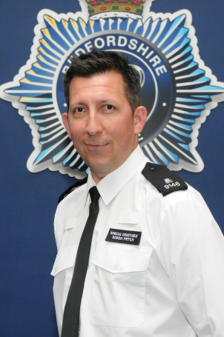SC Simon Petch is one of our newest Special Constables. Simon is a Deputy Head teacher and hopes to fit his volunteering in around his day job. He was encouraged to join the Specials after his school started working with officers as part of the Junior Police Squad programme.

[“I thought I’d never be able to fulfil this dream…”](https://bedspolice.wordpress.com/2017/07/17/i-thought-id-never-be-able-to-fulfil-this-dream/)

I wanted to be involved with the police from a young age – my uncle was a police driver in Northumbria and often when we visited he’d show us the police cars which I found really exciting.

As I went through school I got involved with sports coaching, and on the recommendation of one of my teachers I moved into teaching. I qualified in 1996 and started work straight away.

I began my career, and gradually moved my way up to a point where starting a new career would have been difficult.

All that time I still had an interest in policing, but because I was so immersed in teaching I just assumed that was it and I’d never get to fulfil that dream.

My cousin is also a police officer and we’d spoken about the Special Constabulary before, but the catalyst was really when the Junior Police Squad started working in my school and I got to know the officers running the scheme.

I spoke to them about joining and one told me they would have me in as a Special within a year, but I wasn’t sure how realistic that was! As it turns out, that’s what happened.

The training has been first rate, particularly our two training Officers who have been brilliant. Because of their knowledge and the time they’ve been doing the job, they’ve been able to give practical examples of the things we’ve been learning about.

They have a genuine desire to help people, and if there have been any issues they have been proactive in resolving them.

It has been challenging and you have to get used to thinking on your feet; you are put under pressure and made to think about what you would do in certain situations.

I’ve built brilliant friendships, and I will probably stay in touch with those people forever even if we are based in different areas. It’s been great and I’ve actually really enjoyed learning something from the beginning again.

I’ve finished my initial training and have attested, which means now I’ll be supported by regular police officers and other Specials for about two years before I become an independent Special.

Some people have asked me how I’m going to fit in my volunteering with my job, but I’m going to treat it as a hobby. Whereas some people would make time to go golfing, I will make time for my volunteering.

A clichéd response about why I wanted to join is that I wanted to make a difference, but I do genuinely believe I will be doing that!

It sets a really good example to the children I teach as well. And hopefully what I’m doing shows how much respect I have for the officers who have been working in my school with the Junior Police Squad.

I’m looking forward to getting involved and I don’t think I’ll ever get too tired of the blue lights and sirens! I also want to get involved in community events and issues, particularly those that will affect my community or the children and families I work with in my day job.

I love my job and this is a great way of fitting in something else I’m passionate about as well. I expect to do most of my volunteering at the weekends, and during the school holidays I hope I’ll be able to contribute significantly more.

Although the hours can be anti-social and the training does take commitment, I really would encourage people to think about joining if policing is something you’re passionate about.

***Recently, Simon Petch was awarded “Special Constable of the Year” in the 2018 Annual Police Awards, a well deserving Special Constable who is testimony to how volunteering makes a difference both personally and for the force.***

**Notes Page**

Keep track of your progress

|  |
| --- |
|  |
|  |
|  |
|  |
|  |
|  |
|  |
|  |
|  |
|  |
|  |
|  |
|  |
|  |
|  |
|  |
|  |
|  |
|  |
|  |
|  |
|  |
|  |
|  |
|  |
|  |
|  |
|  |
|  |
|  |
|  |
|  |
|  |
|  |
|  |
|  |
|  |
|  |
|  |

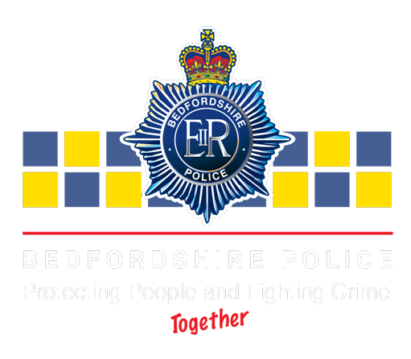



**FIND US ON**

**CONTACT US**



@bedspolice @bedsspecials



Bobbies on the Beat blog

www.facebook.com/bedspolice

Headquarters, Woburn Road, Kempston, Bedford, MK43 9AX

01234 846978

CIP@bedfordshire.pnn.police.uk

www.bedfordshire.police.uk